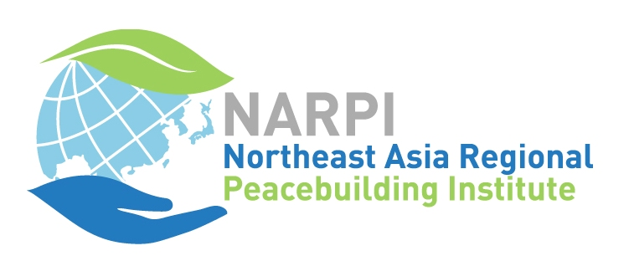
Northeast Asia Regional Peacebuilding Institute
2018 Summer Peacebuilding Training Application
Deadline for Application: May 31, 2018
1. Personal Information
Name
Name | Family name |  | Given names
Name you preferred to be called
Gender |  |  | Date of birth
Email address
Home
address
Zip code |  |  | Country
Mobile phone
Organization
Organizational
address
Office phone |  |  | Fax number
Type of  organization | NGO | School/  University |  | GO |  | Religious |  | Other
Job title
Is your organization aware that you are applying to NARPI? Yes No |  |  | If we call you, what phone number should we use?
Sponsoring organization (if applicable)
First  language |  |  | Other  languages
Passport  Number |  |  | Place of  Issue
Date of issue |  |  | Expiry date
Special needs
(food, physical challenges, etc.)

2. Course selections
Each week NARPI will offer three courses. You can attend only one course per week. Below, please select 1 for your first choice and 2 for your second choice.

There will be a maximum of 20 students per class. All courses will be conducted in English.

Week 1: August 9-13
Conflict and Peace Framework
Restorative Justice Paradigm and Its Practice
Optimizing Peace Making by Ending Generational Trauma

Field Trip: August 14-16
I will participate in the field trip
I cannot participate in the field trip

Week 2: August 17-21
Theory and Practice of Peace Education
Peacebuilding Beyond Nationalism and Militarization
Arts, Media, and Peacebuilding

Please continue to Part 3 below.

3. Additional Information
The following must be received before applications are processed.
A. Statement of Experience: Please describe the relevant work and personal experiences that motivate and prepare you for study at NARPI.
B. Statement of Intent: Please describe your objectives for studying at NARPI and the ways in which you expect to apply the training you receive.
C. English ability: All courses at NARPI will be offered in English. Please describe your English level in the areas of listening and speaking. To what extent can you understand presentations in English related to peacebuilding? Are you able to express your opinions in English?
D. Curriculum vitae/Resume (please attach)
E. Letter of Recommendation: Please email a letter of reference from an organization that knows you and your work. The letter should include: how long the writer has known you, a description of your work, and how this training will be useful for you.
F. A copy of your passport (for international applicants, please attach)

E-mail this application form and all attached documents to apply@narpi.net by May 31.
A limited number of scholarships may be offered on a needs basis. Please contact the administration team for more information, apply@narpi.net. The deadline for scholarship applications is also May 31, 2018.

Thank you for your application, and interest in NARPI!

Northeast Asia Regional Peacebuilding Institute
25 Gungchon-ro, Wabu-eup,
Namyangju-si, Gyeonggi-do, South Korea 12269
Tel. 82-70-8817-8690 Fax 82-31-521-8695 www.narpi.net

